Problem 1:

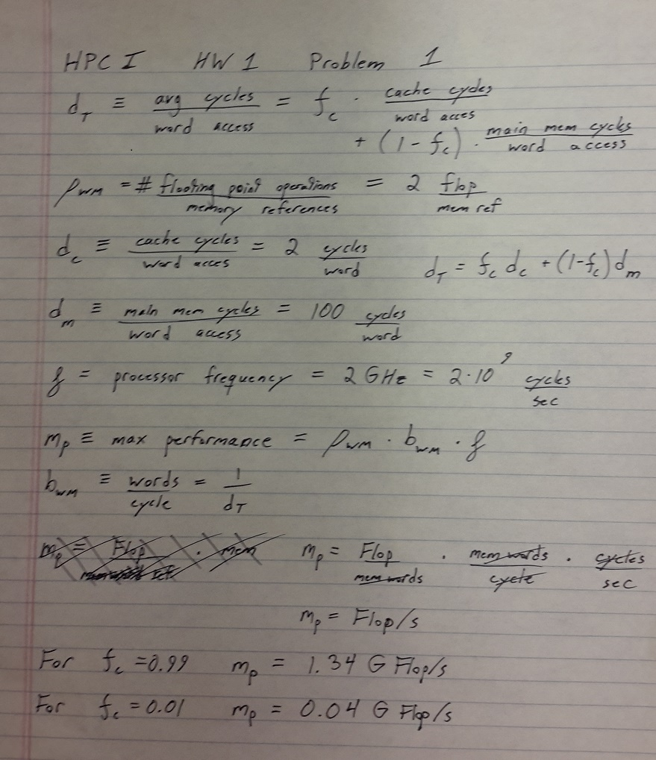

Problem 2: Intel only faster with no optimization, mucks stuff up after that.

Row -> Col is faster since it doesn’t have to step out of the inner loop to pull the next element.



Problem 3: g++ data

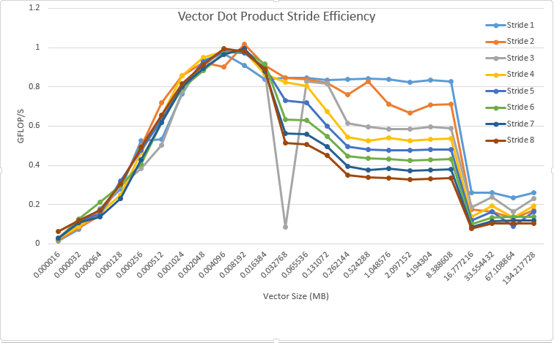

Theoretical limit for my laptop which the above data was gathered on is:

2FLOP/clock * 2.4 GHz = 4.8GFLOP/S

So I’ve achieved just under 25% of the peak performance for a single core.

I’m sure I had finally gotten the mkl optimized version of the dot product working, but wasn’t able to collect the data in time to plot it. The raw data is pasted below.

We can see that the performance reaches ~2GFLOP/S, significantly higher than my naïve dot product implementation.

# Size MFlops/s Error

8 0.000112 0.000000

16 27.758501 0.000004

32 59.259259 0.000004

64 113.394755 0.000010

128 224.877020 0.000016

256 391.676867 0.000070

512 743.321719 0.000035

1024 1289.672544 0.000069

2048 1957.934990 0.000104

4096 2660.431281 0.000114

8192 3209.025384 0.000124

16384 3217.090795 0.000377

32768 2495.126706 0.000206

65536 2592.117962 0.000244

131072 2257.324525 0.000107

262144 1958.806950 0.000150

524288 2134.778756 0.000086

1048576 2051.782975 0.000456

2097152 2242.649732 0.000023

4194304 2281.939340 0.000027

8388608 2239.331167 0.000258

16777216 790.911475 0.000011

33554432 761.207911 0.000015

67108864 582.838794 0.000165

134217728 774.203074 0.000008

268435456 747.860154 0.000091

536870912 780.458946 0.000004

Problem 4:

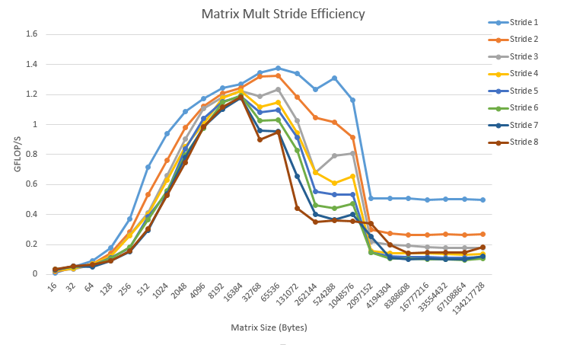

Using mkl –O3 with a matrix of NxN, with N = 2000, corresponding to the furthest right points in the above graph, the efficiency was calculated as 5.7 GFLOP/S, the same order of magnitude but slightly more efficient than the g++ with no optimization.

Note: My Makefile was created to compile the .cpp files from the directories I held them in to organize the data outputs. However, I couldn’t submit directories through UBLearns, and as such ‘make “target”’ may not work without tweaking the Makefile.